Why do we need a compliments and complaints procedure? We want the service we provide to be high-quality, responsive and user-led. In order to achieve this, we need to take account of the views and wishes of the people who use it and having a “compliments and complaints” procedure is one way of doing so.
If you want to make a comment about our service (whether good or bad), we will be pleased to hear from you. Don’t think this will affect the service you receive or that you will be thought of as a nuisance by complaining.
Who can compliment or complain?
Anyone who comes into contact with trustees, staff or volunteers from Crossroads Braintree & Chelmsford can give a compliment or make a complaint, including service users (both carers and those with care and support needs), their families and friends, other voluntary groups, statutory agencies and members of the public in general.
Please note; we can only accept complaints from a representative on your behalf under certain conditions. You will need to have given them your consent either verbally or in writing or we will need to establish that they ae acting in your best interest before we can deal with the complaint.
What you can do
We hope that the majority of concerns and complaints can be dealt with informally. Speak to your care worker, Care Coordinator or a staff member you know. They will listen carefully to what you have to say and do their best to sort the matter out.
If you would prefer not to handle your complaint that way, we have a Complaints Manager who can meet up with you in person, or you can contact by telephone, email or in writing. You can ask a friend, relative or staff member to help you to do this if you wish.
Our Complaints Manager will advise you what further action you need to take and give you information about local advocacy services available to help you.

Contact details for the Complaints Manager are as follows:
Name: D Perry
Address: Unit 307, Lakes Innovation Centre, Lakes Road, Braintree
Postcode: CM7 3AN
Telephone number: 01376 529985
Email: crossroads1974@outlook.com
If you make a complaint in person or on the telephone, the Complaints Manager will:
- Make a written record of your complaint
- Provide you with a copy of the written record within three working days
You will be asked to approve the contents of this report and to sign to indicate that you agree with what it says.
Your complaint will normally be:
- Acknowledged in writing within three working days
- Responded to within 30 working days
Complaints will be investigated by a person who has the right level of knowledge and skill and sufficient seniority to address the issue.
Your complaint will be dealt with in the strictest confidence. If it concerns a member of staff, the person concerned will normally be informed, unless you specifically request otherwise, in which case this may limit the content of further investigation.
You will be kept informed about the process of our investigation or you can contact the Complaints Manager at any time for an update.
You can also complain to your Local Authority or to the Local Government Ombudsman at any time during the complaint process.
What if I am not satisfied?
Following the investigation, if you are not happy with our response, you are entitled to have your complaint reconsidered by a review panel consisting of at least two members not previously involved. If you decide to do this, contact the Complaints Manager within 20 working days of receiving our investigation response and ask for a review of the decision taken.
You will then be notified in writing with details of the time and place of the review meeting at least 10 working days beforehand, and they may attend if you wish. You can bring a friend or relative along with you, or alternatively you may want your friend or relative to attend and speak on your behalf.
We will
- acknowledge your request for a review within three working days
- Carry out the review within 20 working days of receiving your request.
The review panel will let you know in writing its decision and the reasons for it within 10 working days of carrying out the review. This is the final stage of our complaints procedure.
The Local Government Ombudsman (LGO)
If you are still not satisfied with the outcome of our investigation you can complain to the LGO who provides a free independent service. You can contact the LGO Advice Team for information or advice, or to register your complaint.
Telephone 0300 061 0614
Email advice@lgo.org.uk
Website www.lgo.org.uk
Care Quality Commission (CQC)
You have a right to alert the CQC of any concerns or complaints you have. They are happy to receive information about our services at any time but cannot get involved in or investigate individual complaints.
Care Quality Commission
Citygate
Gallowgate
Newcastle upon Tyne
NE1 4PA
Telephone 03000 616161
www.qcs.co.uk/cqc/compliance
Local Authority
Essex County Council, County Hall, Market Road, Chelmsford
CM1 1QH 0345 743 0430

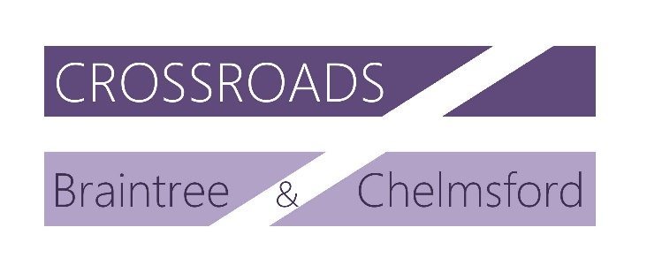

Crossroads Braintree & Chelmsford
COMPLIMENTS AND COMPLAINTS

Our compliments and complaints procedure explained

Crossroads Braintree & Chelmsford
Contact details
Unit 307
Lakes Innovation Centre
Lakes Road
Braintree
CM7 3AN
01376 529985
Charity registration number 1059393 Crossroads Braintree & Chelmsford is a company limited by guarantee Registered in England number 3257547

